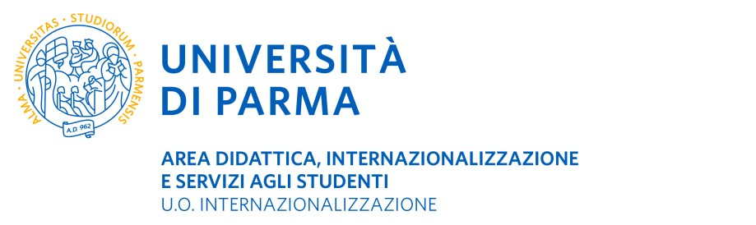

ERASMUS+ SMS
Academic Year 2023-2024
CERTIFICATE OF ARRIVAL AT HOST INSTITUTION
TO BE SENT WITHIN 5 DAYS FROM THE ARRIVAL DATE (to be scanned and sent by e-mail) TO:
U.O. Internazionalizzazione – Erasmus and International Home P.le San Francesco, 3 – 43121 Parma – Italia erasmus@unipr.it

It is hereby certified that (name of student), Erasmus+ student coming from the University of Parma (I PARMA01) arrived at (name of Host Institution), ERASMUS+ code ,

On / / and has been registered as an exchange student at this institution for the
(dd/mm/yyyy)
academic year 2023/2024. The exchange student is expected to spend a period of months.

The exchange student intends to complete a (please tick as appropriate):

PHYSICAL MOBILITY (attend regular classes in presence at the host university.)
The physical mobility period will be from / / to / / (dd/mm/yyyy) (dd/mm/yyyy)
BLENDED MOBILITY (may attend a mix of classes in person and online whilst residing in this host university.)
The physical mobility period will be from / / to / /
(dd/mm/yyyy) (dd/mm/yyyy)
The virtual mobility period will be from / / to / /
(dd/mm/yyyy) (dd/mm/yyyy)

VIRTUAL MOBILITY (attend online classes from their home in their home country. They will not receive an E+ grant or status as they are not completing the mobility abroad.)
The virtual mobility period will be from / / to / /
(dd/mm/yyyy) (dd/mm/yyyy)

Date ____________________
Signature of the officer in charge for international student mobility
under the Erasmus+ Programme at host institution

Stamp of host institution

_____________________________

